**Demonstration of knowledge in SQL**

1: Set Operations

Set Operators are commonly used to combine tables of like data keeping all or excluding duplicates. They can also be used to pick out common data types or the opposite finding only that do not match. These can be used in situations where like in an inventory you would like to see how similar your products are store. Its a useful comparative tool.



The only use I could find for it on a single table as assignment described was not supporting the INTERSECT operator. Set operators should be used with 2 tables and I was only given 1 to work with.

2: Subqueries

Subqueries are very simple in the fact that they are just nested queries. They simply give the access to select something that matches something your selecting from another table or within the same table. This is useful for finding data between tables where they match as well like simply put an employee ID across DB’s where all this data is separated like home and address in on and other contact info in another table. 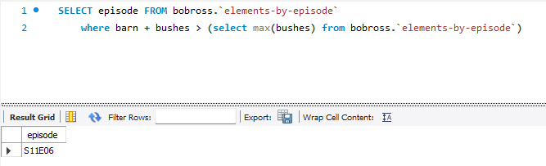

The returned result shows all episodes that have barns and bushes. Sort of a silly way to demonstrate subqueries but non the less it works.

3: Order of Operations

The basic order of operations is SELECT, FROM, WHERE. There are other things you can add in such as where’s and other similar queries. The structure has to be comprised of the first 2 listed above or nothing will work. All code has an order of operation and if you’re ever confused how to use it a quick search on the internet can help you find examples of where people put it and even places it you wouldn’t think it might work.

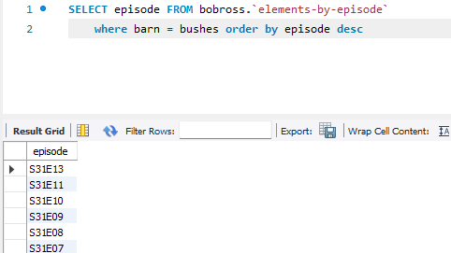

4: Creating, Altering, Dropping tables

When running a database you will be asked at times to create new data structures or you may decide to do so on you own so you will need to CREATE TABLE. Sometimes you will need to change the data in that table or change the rows and columns descriptions and this can be done with ALTER. Sometimes you will actually just need to simply delete a table and that can be done with DROP.

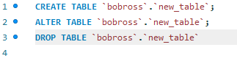

5: Associations

Associations are how tables know how they work together in a database. You will need keys to accomplish this. Primary key and foreign key. There are 4 different types of table associations of tables , one to one, one to many, many to one, and many to many. These will be used according to how you need everything related. Basically 1 apple per person, one apple for multiple people, multiple apples for one person or ... (multiple apples for one person and multiple people for on apple).

I only have one bob ross table which is not related to anything and also do not have a screenshot because of this.

6: join and multiple table joins

Joins is similar to union bust instead of creating a list comprised of like and unlike data it instead adds more columns to the left or right depending on how you put everything. This is useful for taking data from multiple tables to display instead of (for example) an employee number but a name instead while going through data to make something more presentable and easier to deal with.

